**LAB # 04**

**ARRAYS IN JAVA**

**LAB TASKS**

1. Write a program that takes two arrays of size 4 and swap the elements of those arrays.

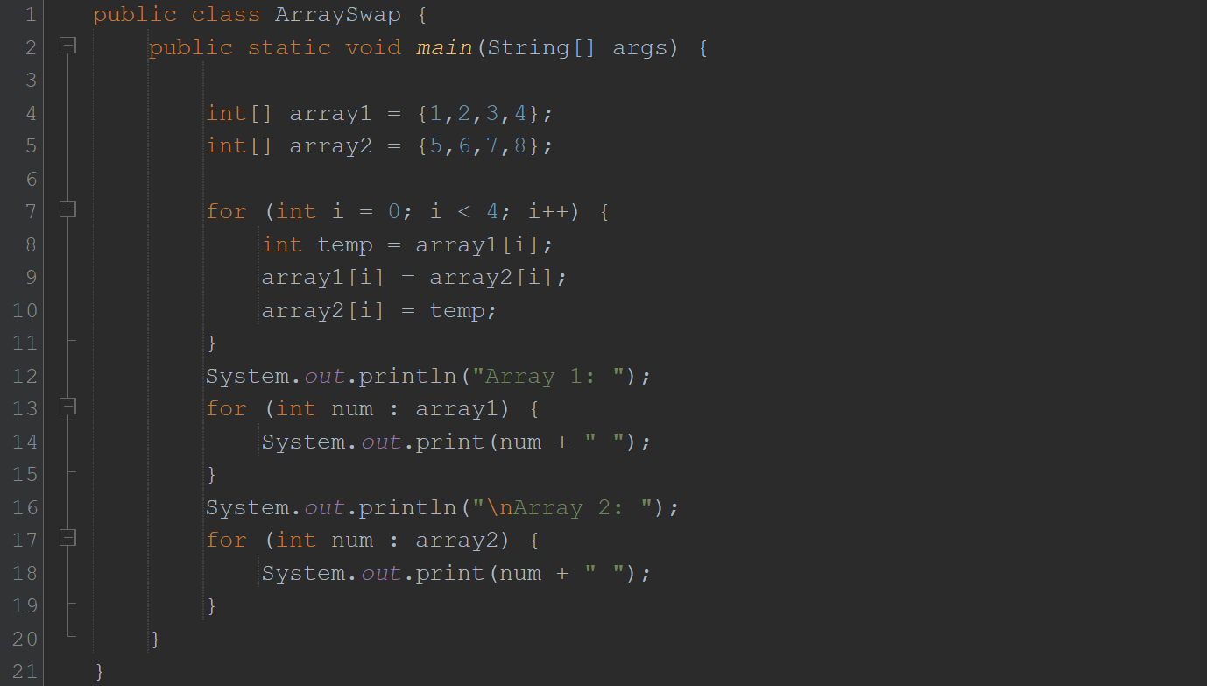

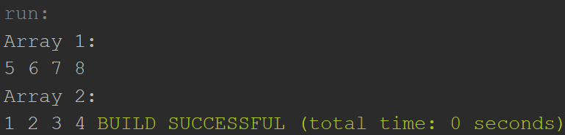

2. Add a method in the class that takes array and merge it with the existing one.

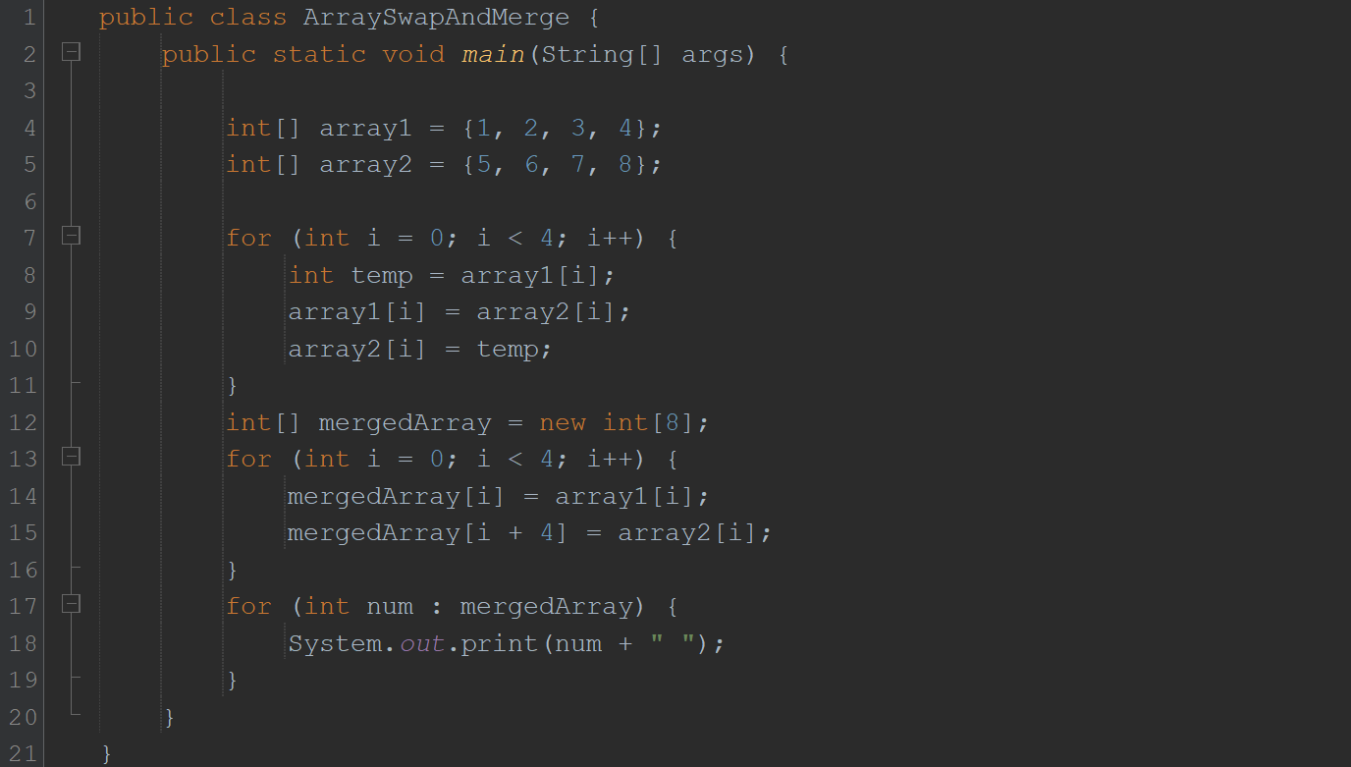



3. In a JAVA program, take an array of type string and then check whether the strings are palindrome or not.

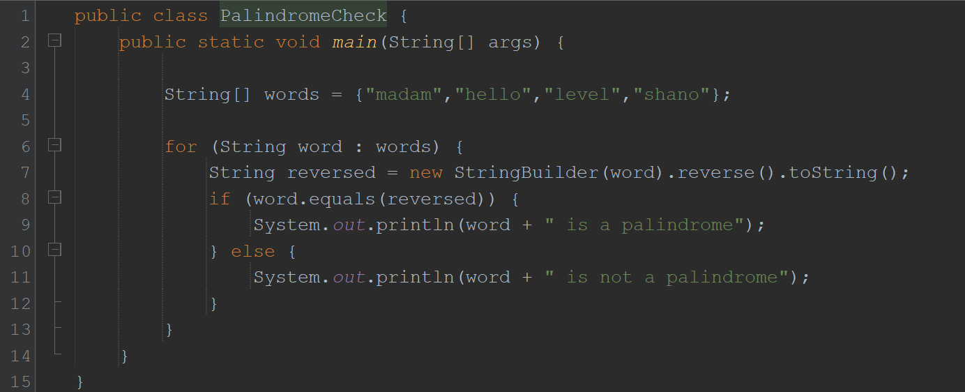

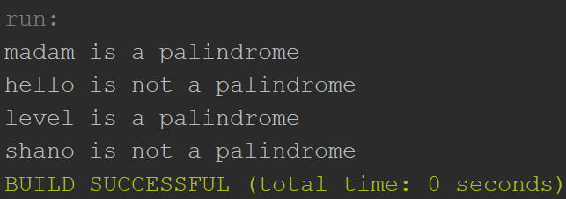

4. Given an array of integers, count how many numbers are even and how many are odd.

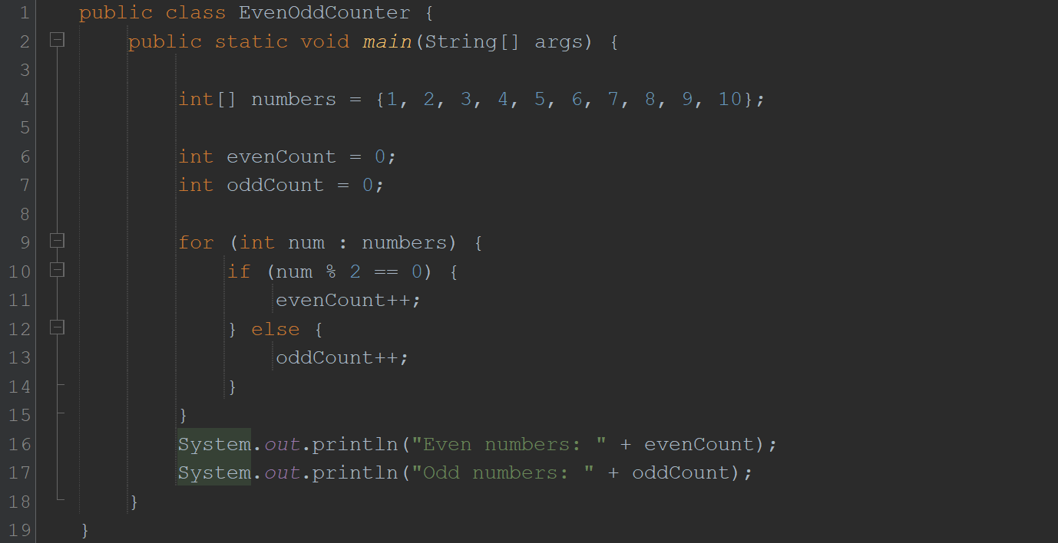

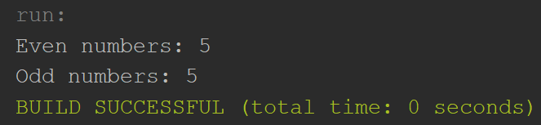

5. Given two integer arrays, merge them and remove any duplicate values from the resulting array.

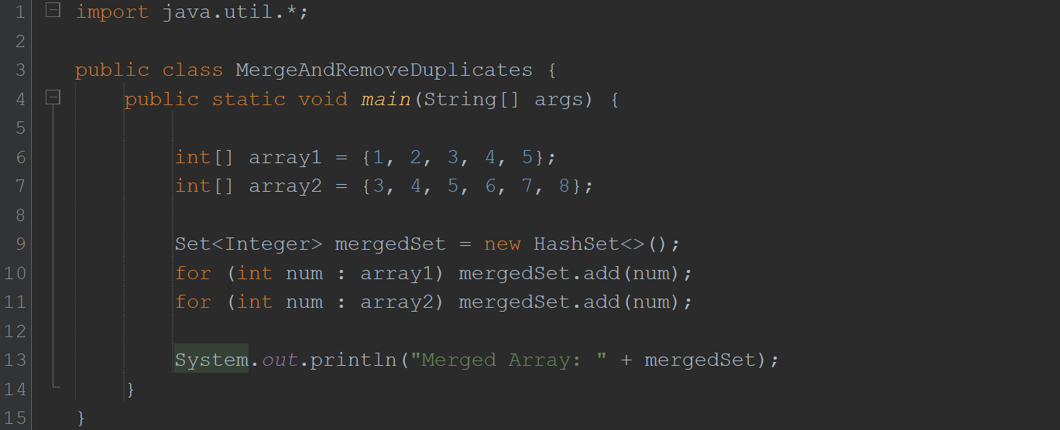

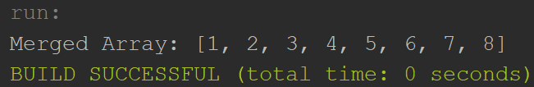

**HOME TASKS**

1. Write a program that takes an array of Real numbers having size 7 and calculate the sum and mean of all the elements. Also depict the memory management of this task.

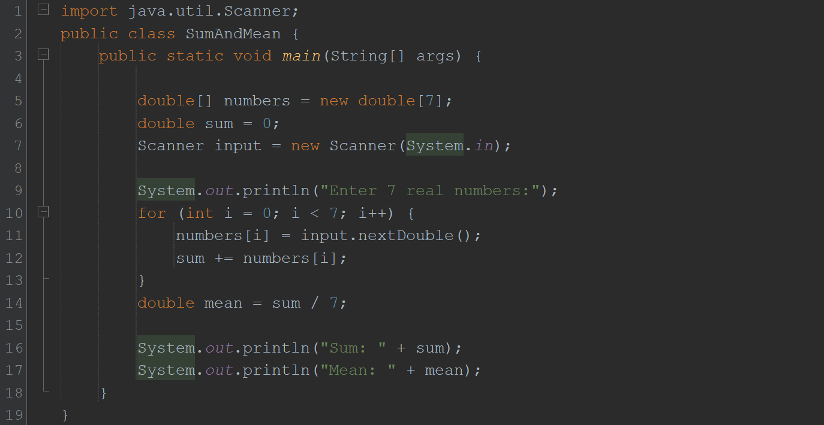

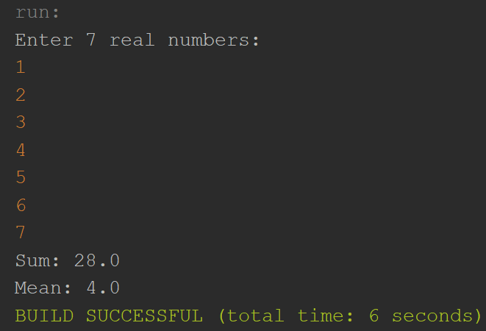

2. Add a method in the same class that splits the existing array into two. The method should search a key in array and if found splits the array from that index of the key.

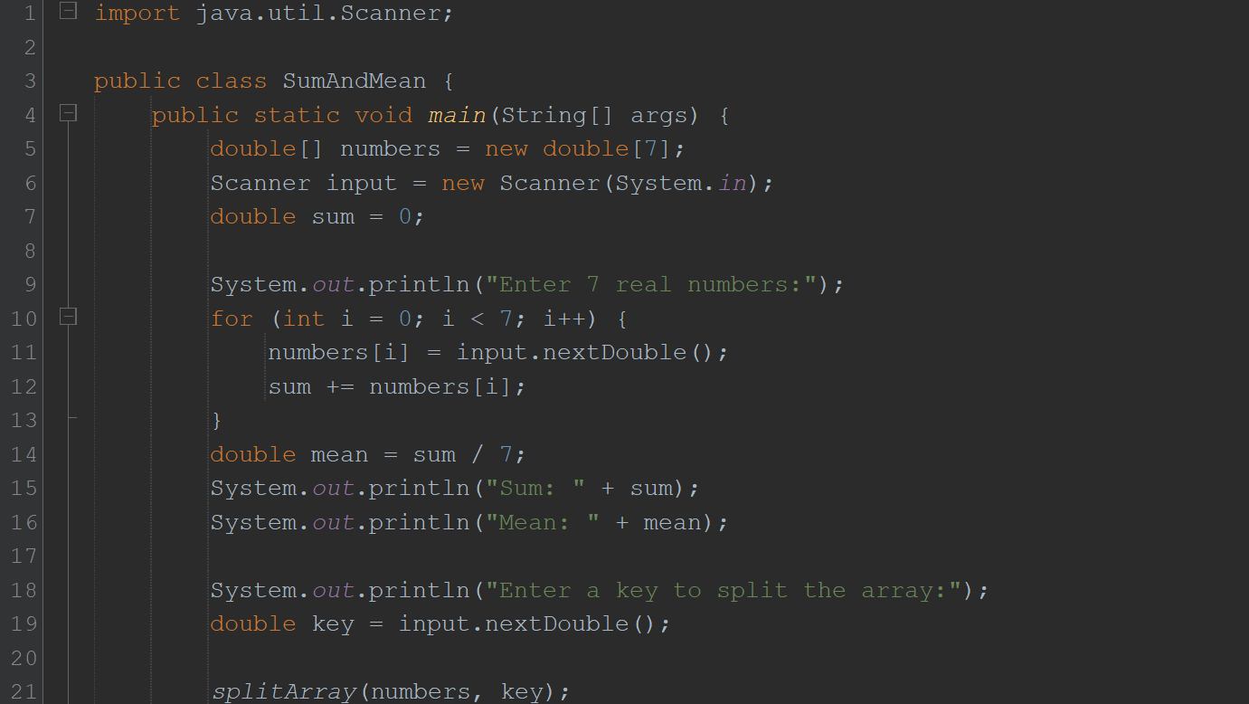

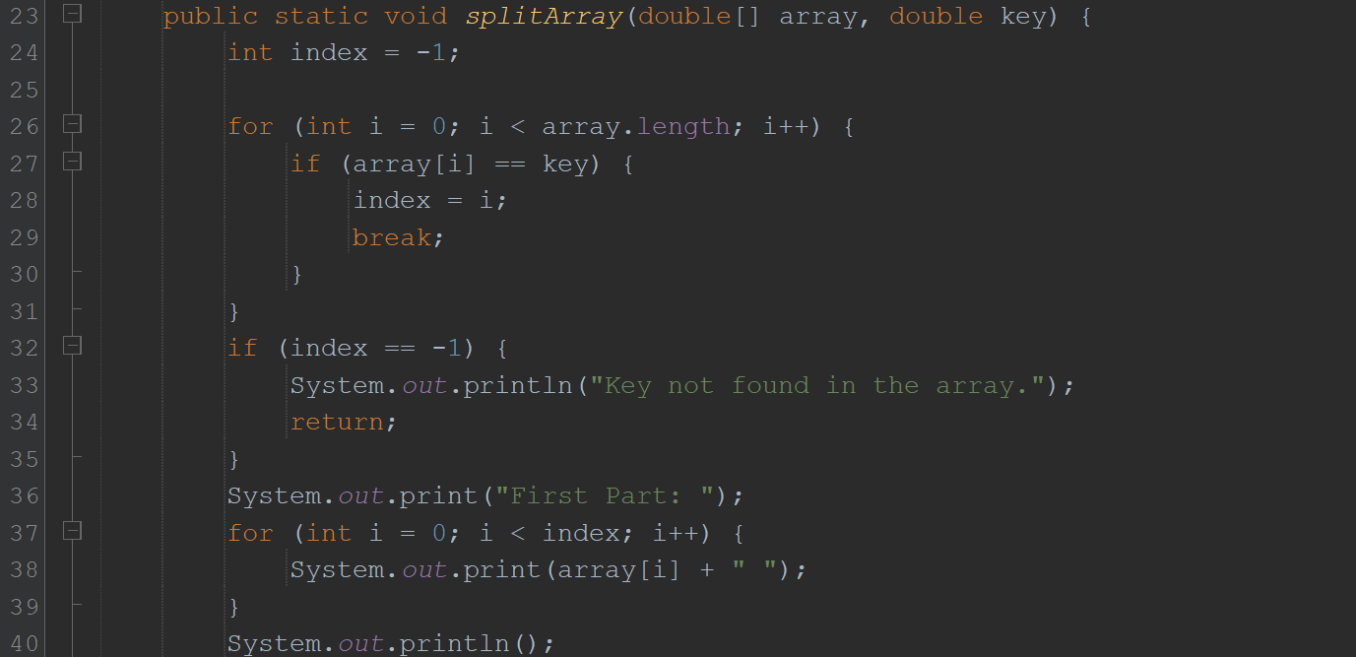

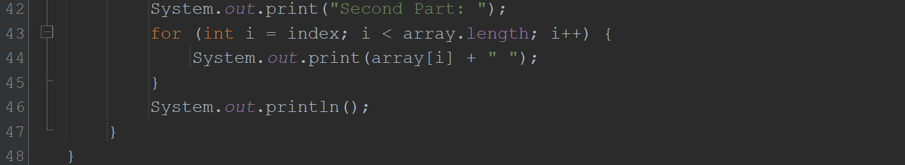

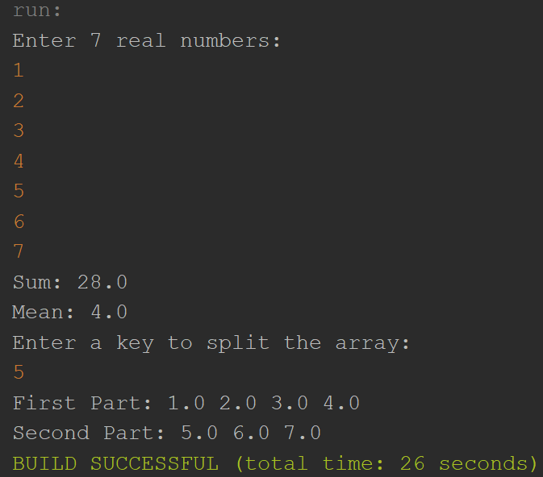

3. Given an array of distinct integers and a target integer, return all unique combinations of numbers that add up to the target. Each number can be used only once in the combination.

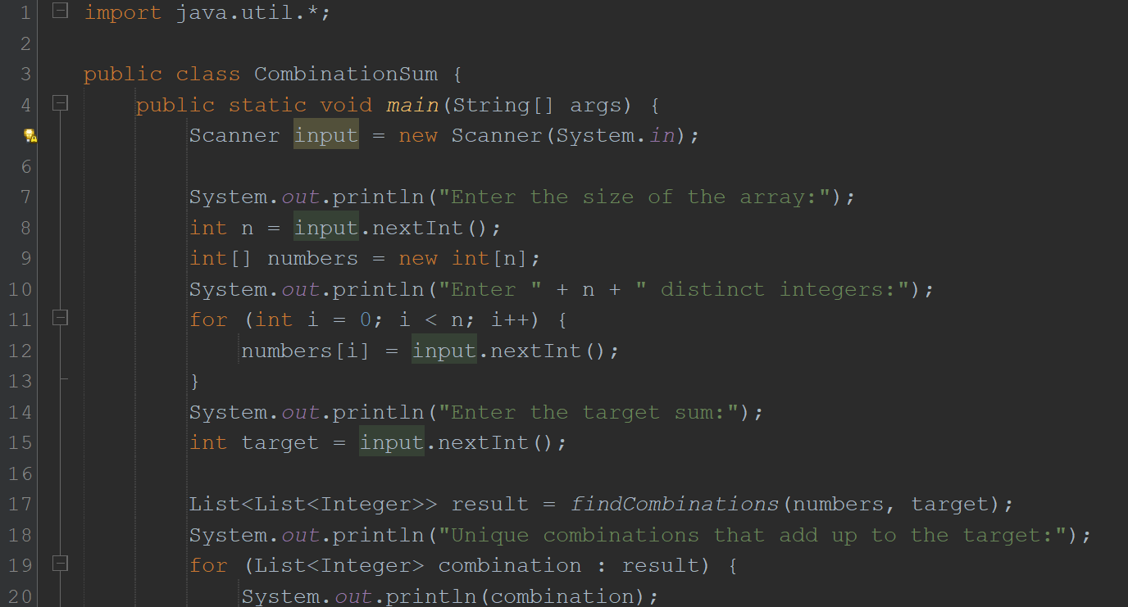

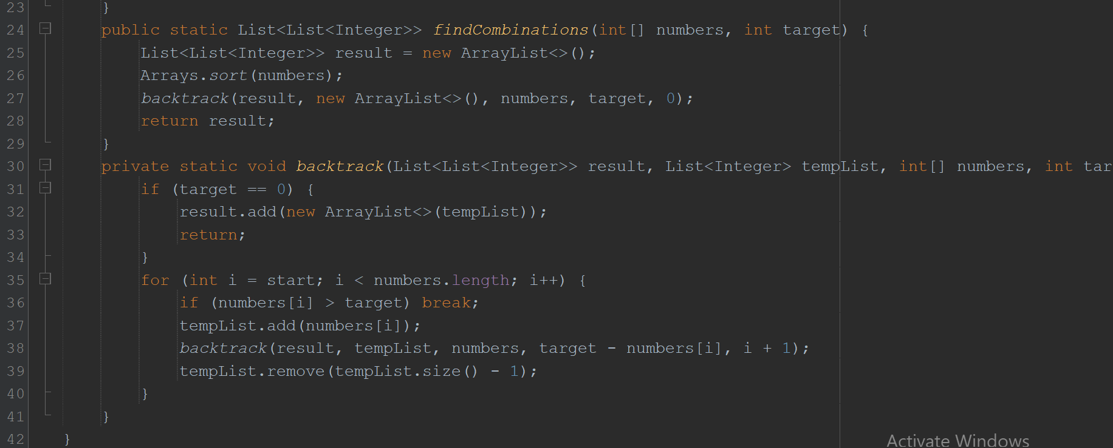

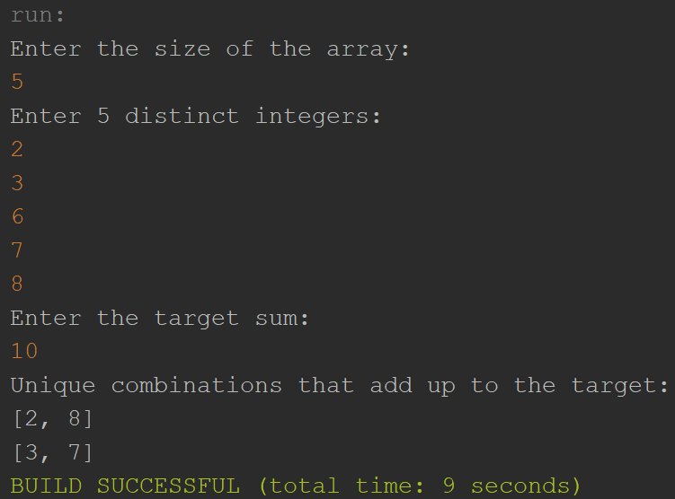

4. You are given an array containing n distinct numbers taken from 0, 1, 2, ..., n. Write a program to find the one number that is missing from the array.

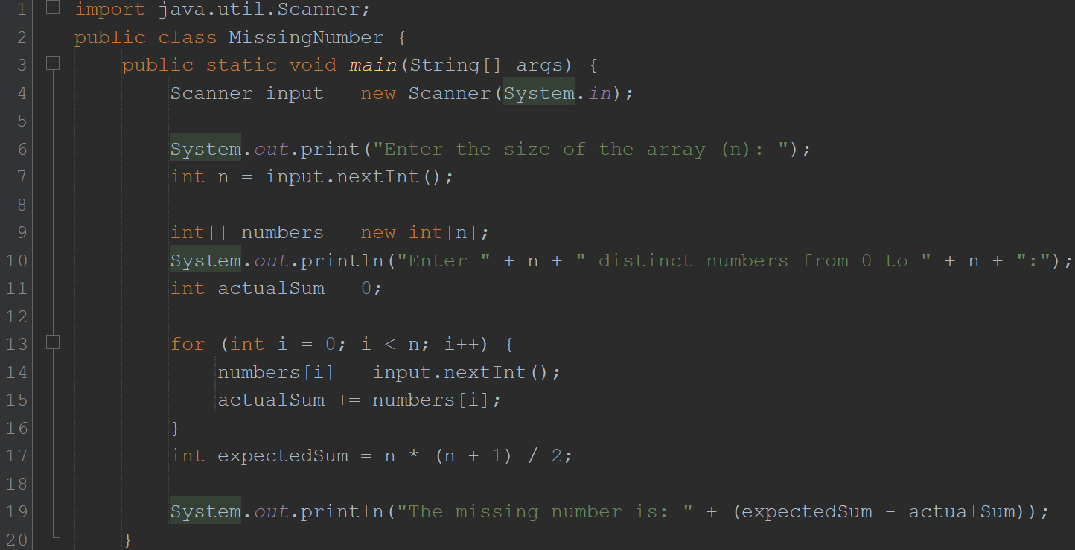

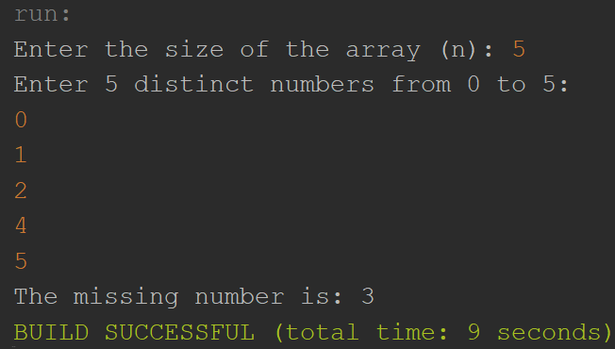

5. You are given an array of integers. Write a program to sort the array such that it follows a zigzag pattern: the first element is less than the second, the second is greater than the third, and so on.

